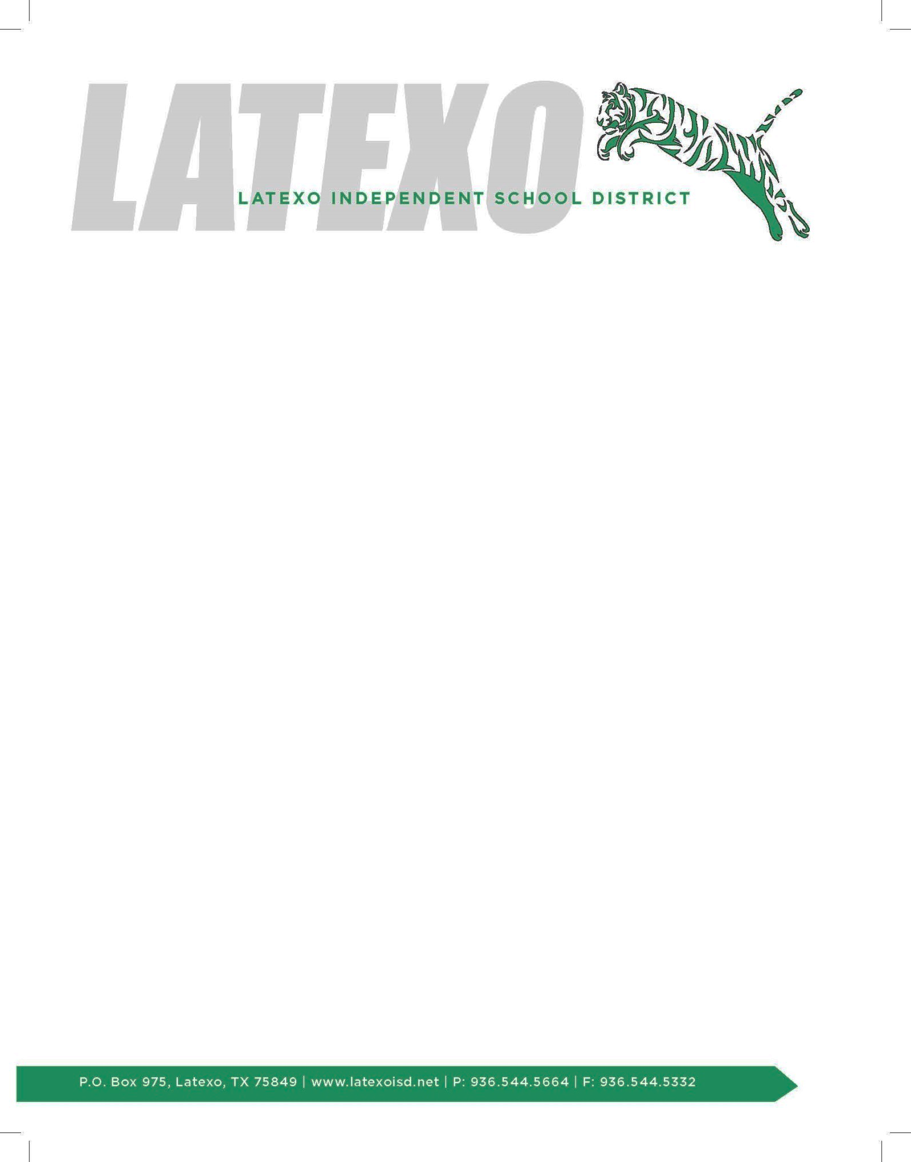

February 4, 2020

I want to let everyone know that last night our school board voted unanimously to call for a school bond election on May 2nd. This decision was made after several meetings and many conversations of what our district and community needs are. The new bond will pay for a multipurpose facility that will seat 600 for district events including graduation, community events like concerts and different type shows, and sporting events. The new bond will also pay for new CTE classrooms at the high school, refacing the front of the high school, and a stand alone elementary cafeteria where we don't have to use the PE gym as we do now. Our district will pay off the current elementary bond payment in February of 2021. Paying off the elementary bond will make it possible to pass the new bond and make these additions to our district without increasing the current I&S tax rate. Interest & Sinking Fund (I&S) is what local taxpayers approve to pay for buildings and new construction in their districts. Our current I&S tax rate is .159 and Maintenance & Operations (M&O) tax rate is .97 for a total tax rate of 1.129. The M&O tax rate is set by the state and this is what pays for our salaries and day to day operations in the district. We are asking the taxpayers to continue paying the tax rate they have been paying (1.129) with no increase to the current total tax rate in the years to come. This will afford our district to make the additions we are wanting to make and not cost our taxpayers anymore than they are already paying.

I just wanted to start getting information out to everyone after our board meeting last night. There will be more meetings and conversations to come as we move forward. Please help me pass the correct information along and feel free to ask any questions you may have. I look forward to seeing the new changes for our district and community.

Thanks!!!

Michael Woodard, Superintendent

Latexo ISD